How to utilize MAPLE to solve linear problems:

e.g.

$$minimize Z=4x_{1}+2x_{2} \\ subject to: \\ 5x_{1}+15x_{2}≥50 \\ 20x_{1}+5x_{2}≥40 \\ 15x_{1}+2x_{2}≤60 \\ x_{1}≥0, x_{2}≥0$$

Graphical method

> with(plots):

> CS:=[5\*x[1]+15\*x[2]>=50, 20\*x[1]+5\*x[2]>=40, 15\*x[1]+2\*x[2]<=60, x[1]>=0, x[2]>=0];

> inequal(CS, x[1]=-1..10, x[2]=-1..10, optionsfeasible=(color=grey), optionsexcluded=(color=white));

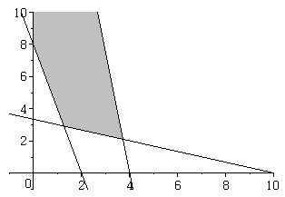

If you want to solve for points of intersection:

> with(simplex):

> Eqns1:=convert({CS[1], CS[3]}, equality);



> solve(Eqns1);



Simplex Method

Since we have already defined constraints,

> Z:=4\*x[1]+2\*x[2];

> sol:=minimize(Z,CS);



> assign(sol); Z;

60