Desmos is a free online graphing calculator equipped with many available applications. Easy to use, the program can graph both 2-D and 3-D functions (however, it’s 2-D plotting abilities are much more developed.)

Eli Luberoff founded Desmos in 2011 and has since been chief executive officer of the company. “He began working on the software […] during a year-long hiatus from Yale University in 2007, returning to graduate summa cum laude with degrees in Math and Physics in 2009. [Luberoff] was also selected by Bloomberg Businessweek as one of the top 25 entrepreneurs under 25 in 2011.” Desmos has received over $1,000,000 of funding from Kapor Capital, Learn Capital, Kindler Capital, Elm Street Ventures and Google Ventures.

Desmos was designed to be accessible to users without backgrounds in coding. All he/she has to do is enter the equation into the calculator. Desmos will graph:
- Regular functions
- Relations
- Inequalities
- Piecewise functions
- Polar equations
- Parametric equations
- Domain and range restrictions
- Points (fixed or movable)
- List expressions
- Regressions
- Integrals
- Equations with derivatives
- Phase planes
- Slope fields
- And more

Regular Functions and the basics
To graph a function into Desmos, simply enter it into the expression list bar, which is found at the left.
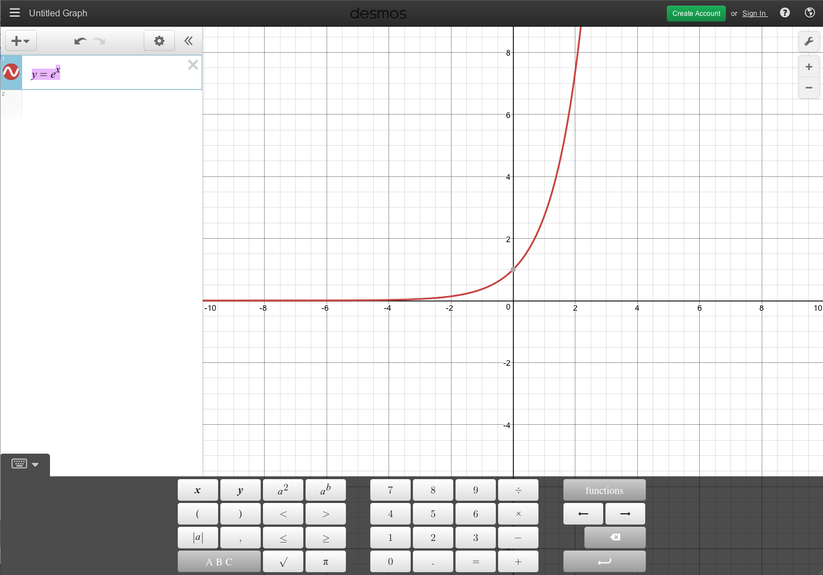

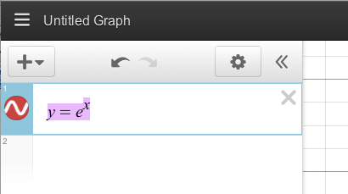

Below is a visual representation of the expression list bar’s features:
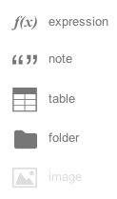

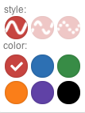
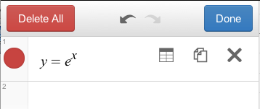

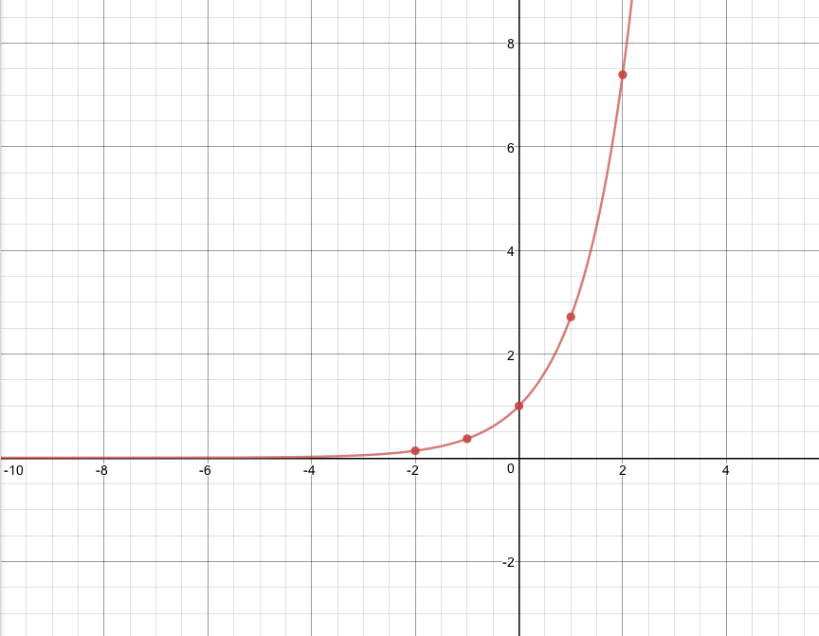
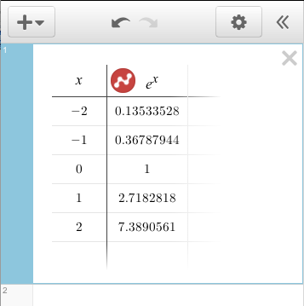

To graph multiple functions simultaneously, click on the empty row underneath the typed function.

If you want to edit the axis, click on the top right icon labeled “Graph Settings.”

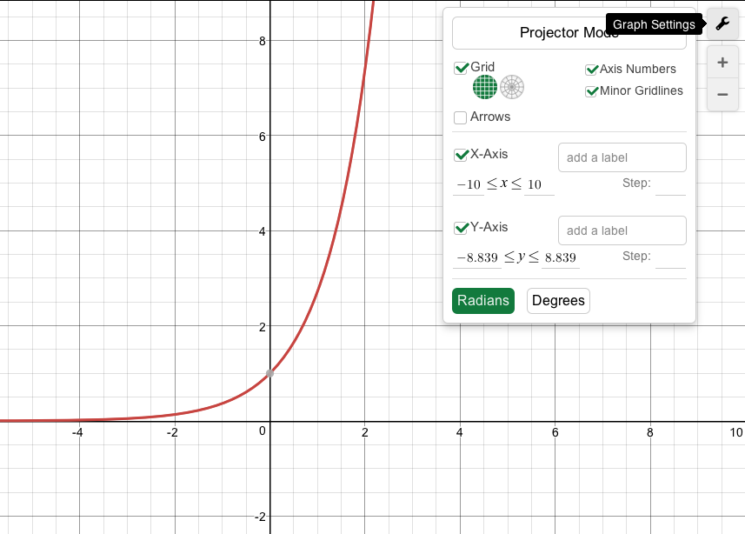

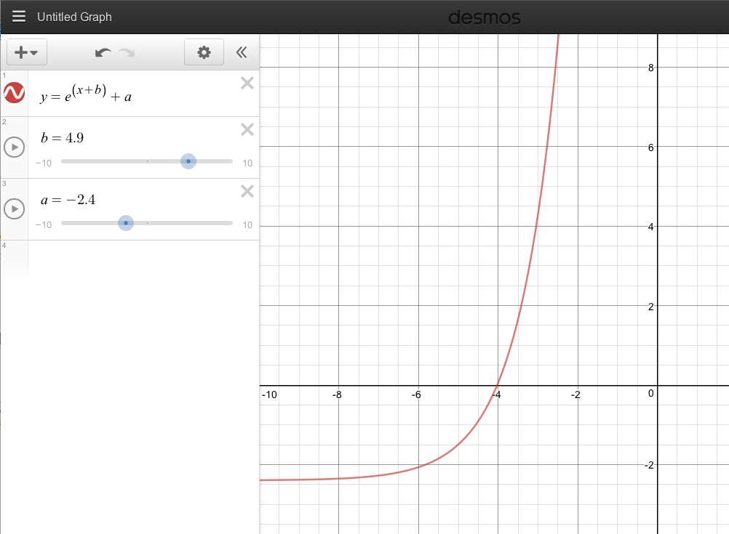
Desmos also includes the ability to transform functions using sliders. Just add and define a new variable:
Relations
In addition plotting explicit functions, Desmos can graph implicit functions or relations:

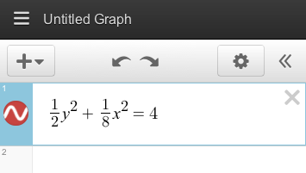

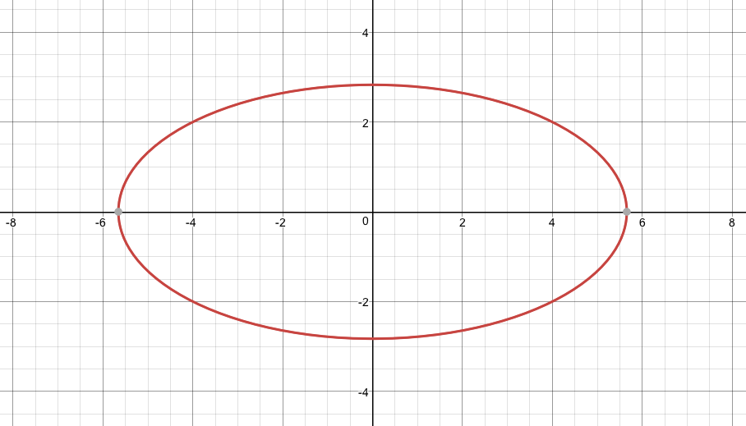

Inequalities
Desmos highlights the areas of interest; gives a defined boundary a solid line; and denotes an excluded boundary by a dashed line:
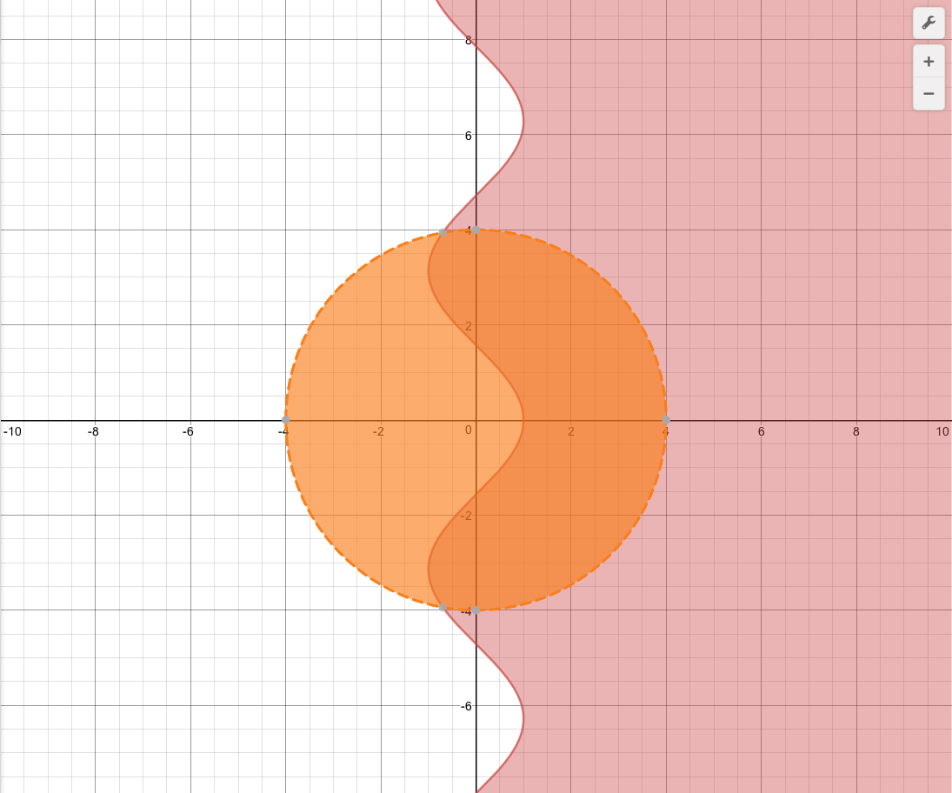

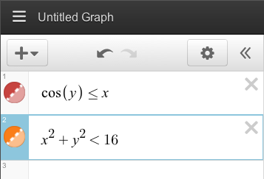

Piecewise functions
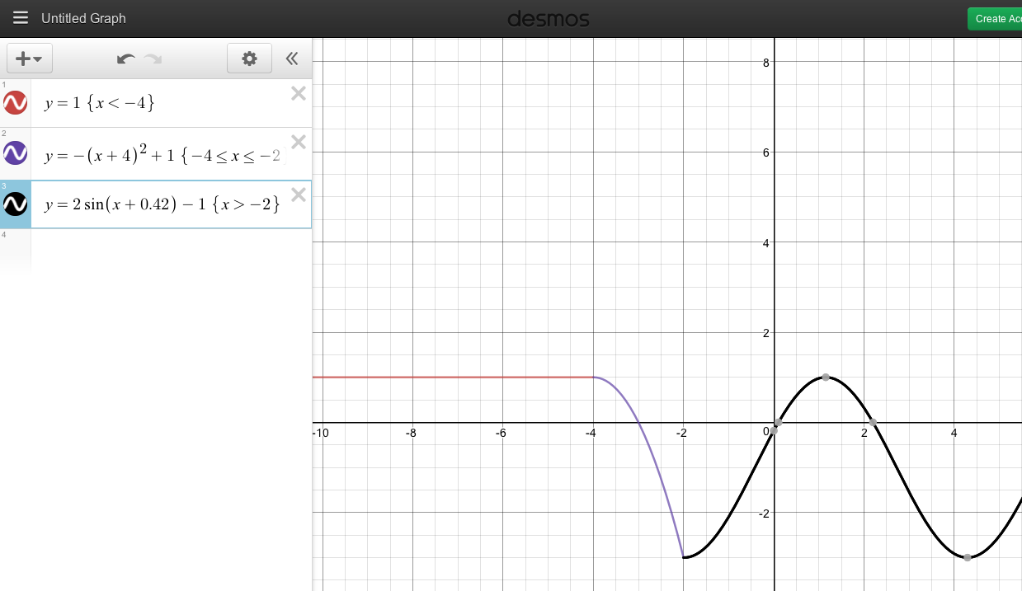
Simply type the restrictions with {} parentheses following the equation or relation:
Polar equations
Desmos can recognize r and theta as polar variables:
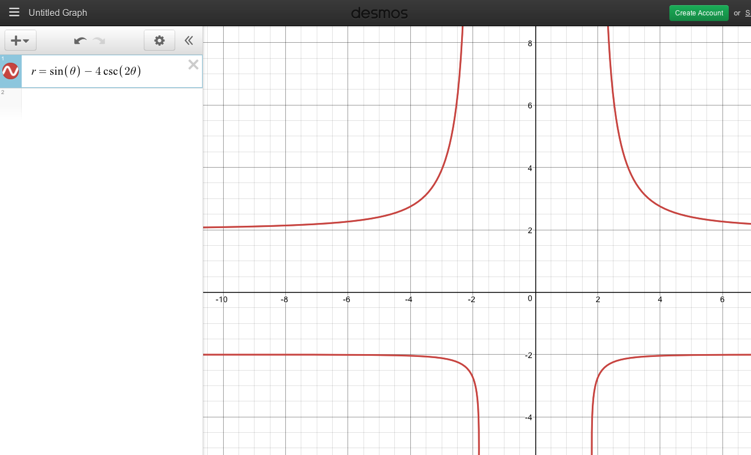

Parametric equations
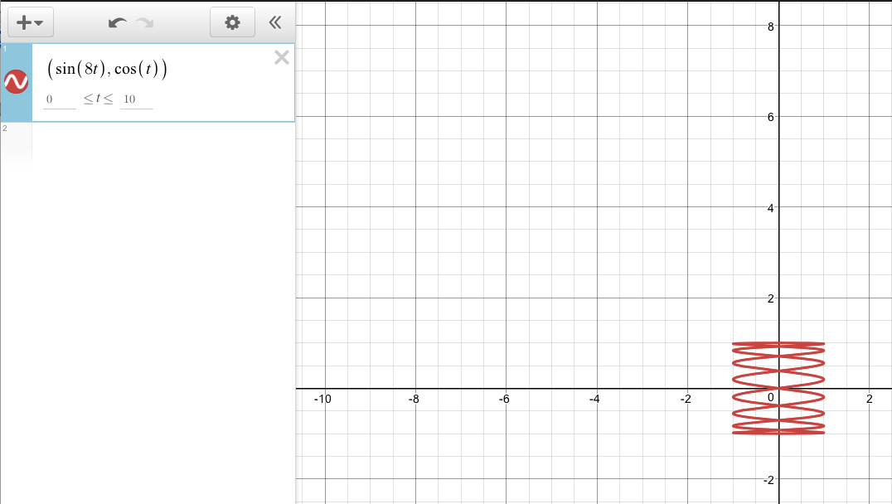
To create a parametric equation, enter the output function in coordinates into the expression list bar. Make sure to use t as your variable:

Equation with derivatives
By defining functions, the user can create such equations:
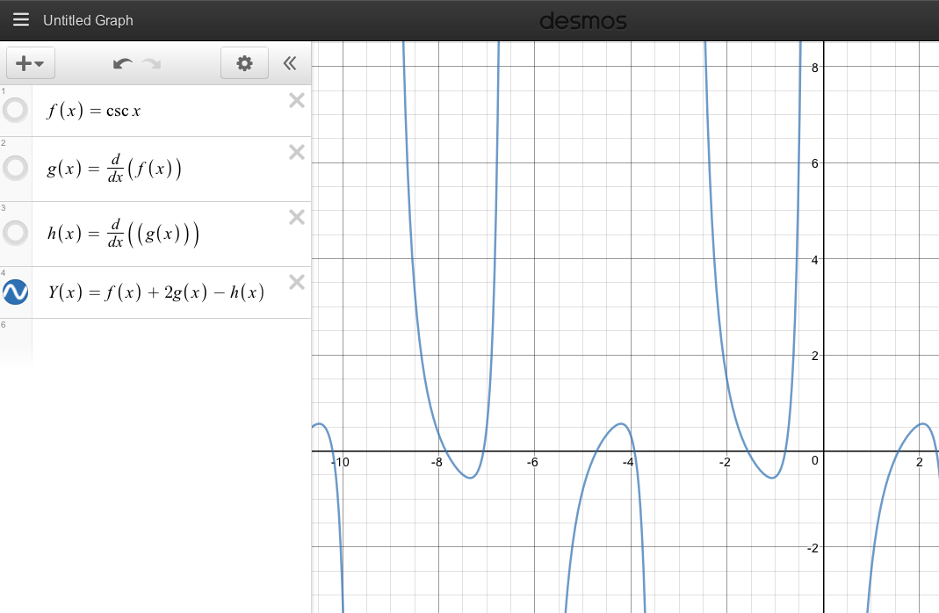
Phase planes
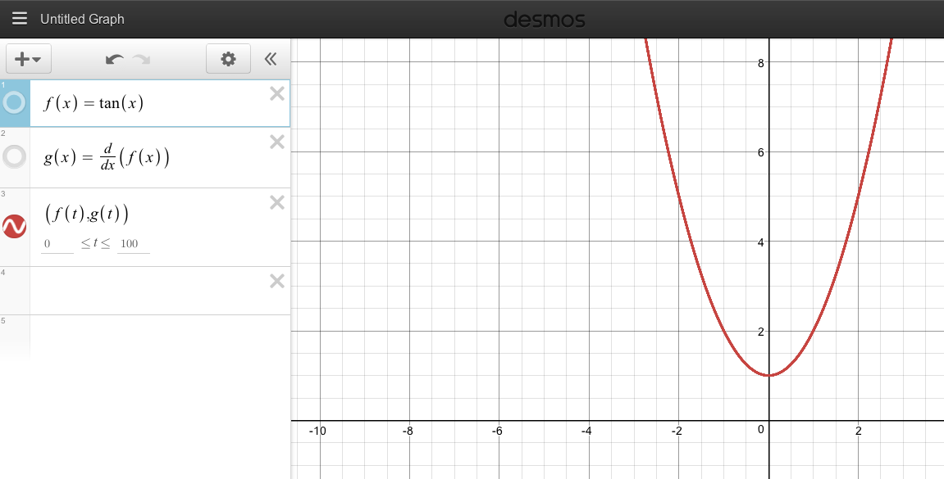
Using parametric equations, one can plot phase planes of functions:
Slope fields
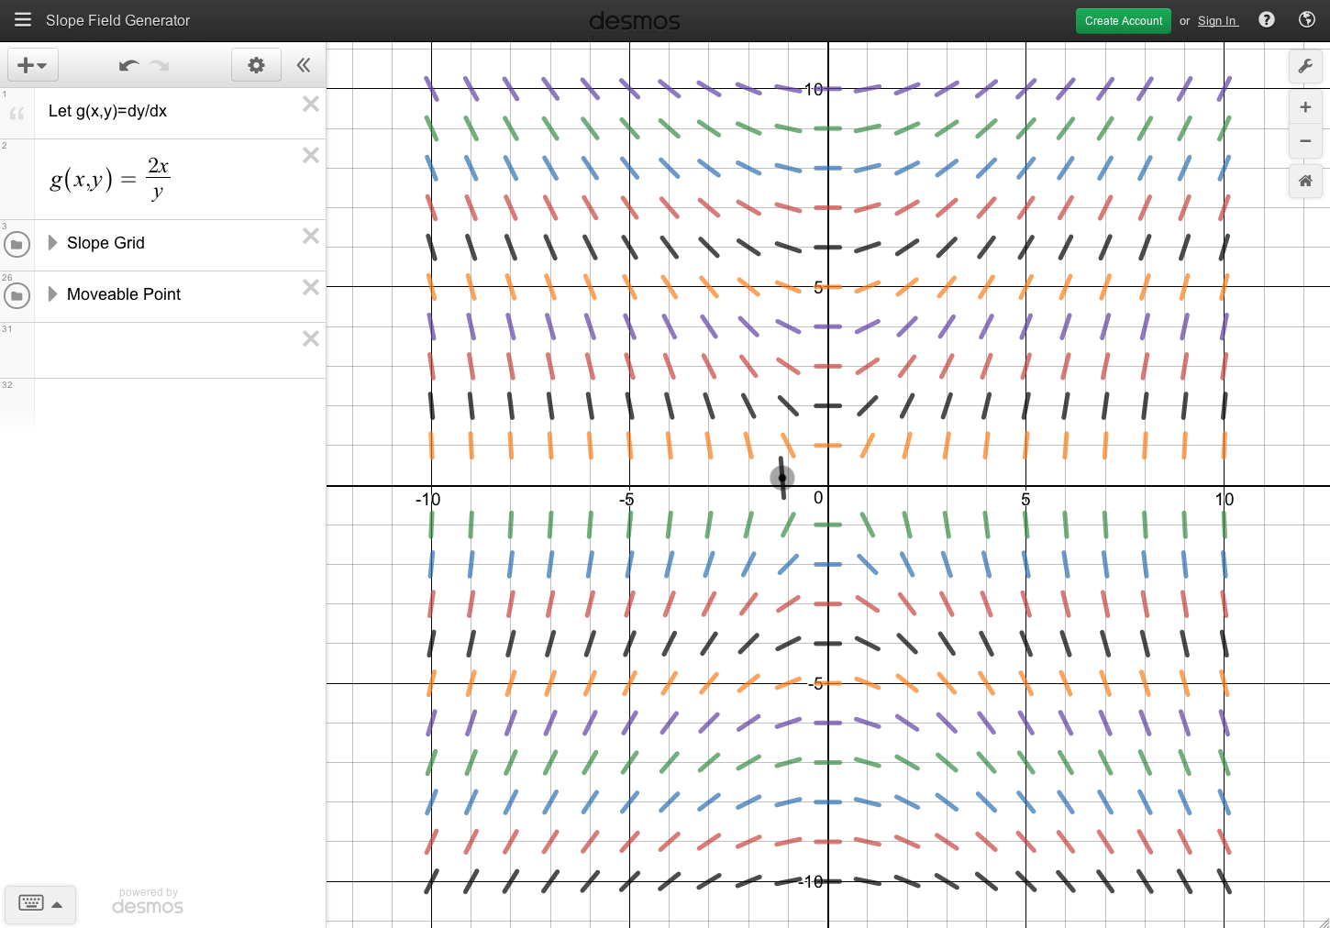
Desmos is also equipped with a slope field generator. Search “Desmos Slope Field Generator” to make use of it:

3D plotting
Desmos has a 3D plotter, which uses parametric lines to graph functions. Search “Desmos 3D Graph” to try it out:

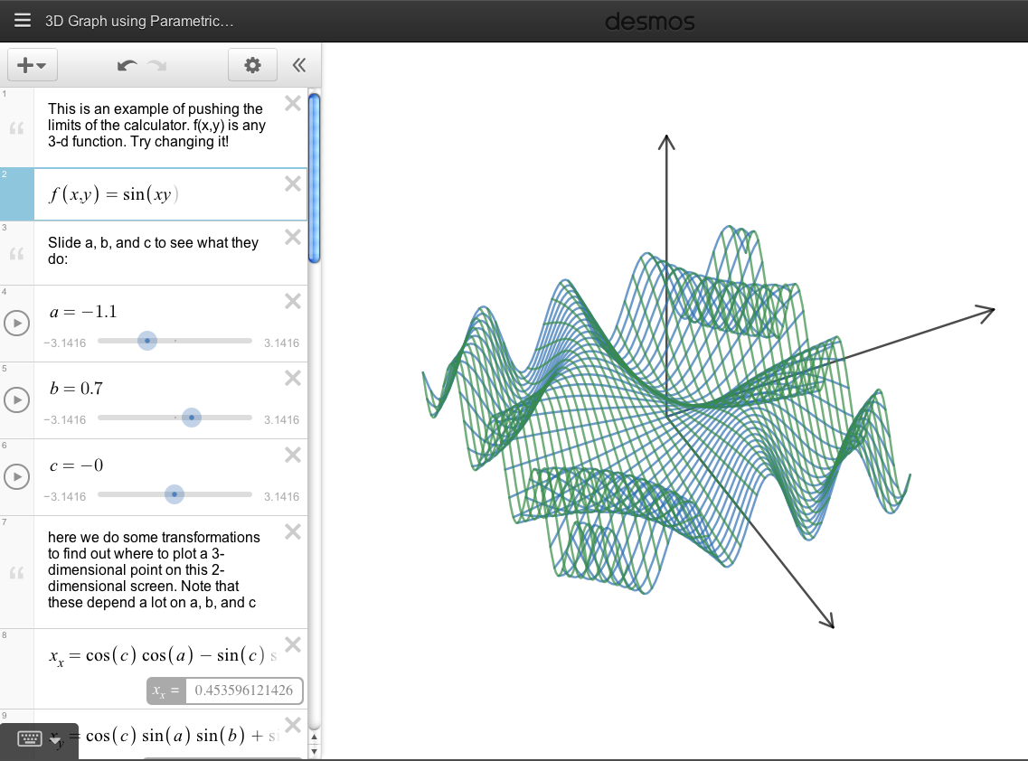

For more information, take a look at this link:
https://desmos.s3.amazonaws.com/Desmos_User_Guide.pdf

"Desmos | Meet Our Team." Desmos.com. N.p., n.d. Web. Jan. 2017.
Heussner, Ki Mae. "Desmos gets Google Ventures funding for next-gen graphing calculator." Gigaom. N.p., 26 Sept. 2012. Web. Jan. 2017.

